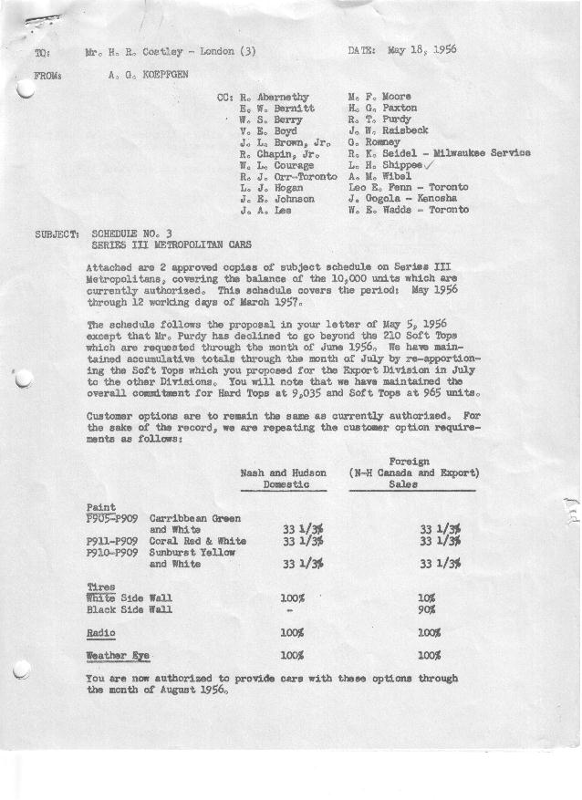

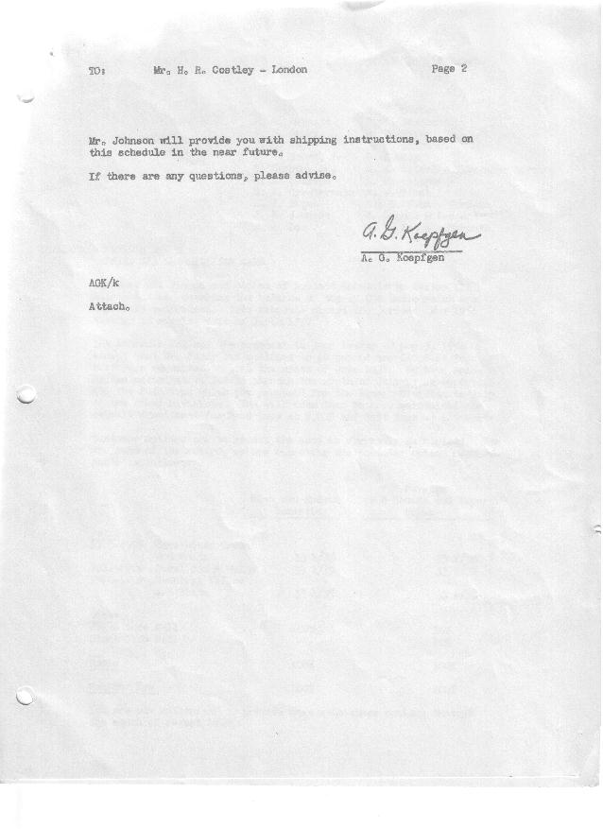

FORM PLAN 68 REV. 2-55-A.M.P Sheet1 of 2 APPROVED R.T. Purdy & W.L. Courage (signed) DATE 5-18-56 & 5-21-56

SCHEDULE NO. ______3 ________ DATE May 18, 1956 MONTHLY BUILDING SCHEDULE APPROVED J.W. Raisbeck (signed)_ DATE_ 5-21-56 ____
REVISION NO. _______ _______ DATE PRODUCT APPROVED_E. W. Bernitt (signed) ___ __DATE _ 5-22-56 ____
Series III 1500 c.c. Engine
Metropolitan Series Cars – Austin Motors Co., Ltd., England
DESCRIPTION | BUILT  ◻ACT◻ EST  THRU  APRIL | FIRM BUILDING SCHEDULE  (FABRICATED MATERIAL RELEASE) |  |  |  |  |  |  |  |  |  |  |  |  |  |  | TENTATIVE SCHEDULE  (RAW MATERIAL RELEASED) |  |  | GRAND  TOTAL
DESCRIPTION | BUILT  ◻ACT◻ EST  THRU  APRIL | MONTH MAY  DAYS 21 |  |  | MONTH JUNE  DAYS 21 |  |  | MONTH JULY  DAYS 20 |  |  | MONTH AUGUST  DAYS 15 |  |  | MONTH SEPTEMBER  DAYS 20 |  |  | MONTH OCTOBER  DAYS 23 |  |  | GRAND  TOTAL
DESCRIPTION | BUILT  ◻ACT◻ EST  THRU  APRIL | DAILY | MONTH | CUM’L  TOTAL | DAILY | MONTH | CUM’L  TOTAL | DAILY | MONTH | CUM’L  TOTAL | DAILY | MONTH | CUM’L  TOTAL | DAILY | MONTH | CUM’L  TOTAL | DAILY | MONTH | CUM’L TOTAL | GRAND  TOTAL
DOMESTIC:
Nash Hard-Top | 1648 |  | 478 | 2126 |  | 505 | 2631 |  | 416 | 3047 |  | 151 | 3198 |  | 290 | 3488 |  | 395 | 3883
Soft-Top | 168 |  | 130 | 298 |  | 100 | 398 |  | 4 | 402 |  | 13 | 415 |  | 0 | 415 |  | 0 | 415
Total Nash U.S. | 1816 |  | 608 | 2424 |  | 605 | 3029 |  | 420 | 3449 |  | 164 | 3613 |  | 290 | 3903 |  | 395 | 4298
Hudson Hard-Top | 424 |  | 180 | 604 |  | 185 | 789 |  | 259 | 1048 |  | 69 | 1117 |  | 150 | 1267 |  | 150 | 1417
Soft-Top | 45 |  | 30 | 75 |  | 22 | 97 |  | 16 | 113 |  | 10 | 123 |  | 0 | 123 |  | 0 | 123
Total Hudson U.S. | 469 |  | 210 | 679 |  | 207 | 886 |  | 275 | 1161 |  | 79 | 1240 |  | 150 | 1390 |  | 150 | 1540
Total U.S. | 2285 |  | 818 | 3103 |  | 812 | 3915 |  | 695 | 4610 |  | 243 | 4853 |  | 440 | 5293 |  | 545 | 5838
FOREIGN:
Export Hard-Top | 154 |  | 68 | 222 |  | 73 | 295 |  | 65 | 360 |  | 67 | 427 |  | 50 | 477 |  | 40 | 517
Soft-Top | 105 |  | 50 | 155 |  | 55 | 210 |  | 0 | 210 |  | 0 | 210 |  | 0 | 210 |  | 0 | 210
Total Export | 259 |  | 118 | 377 |  | 128 | 505 |  | 65 | 570 |  | 67 | 637 |  | 50 | 687 |  | 40 | 727
Canada- Nash Hard-Top | 0 |  | 0 | 0 |  | 0 | 0 |  | 85 | 85 |  | 100 | 185 |  | 80 | 265 |  | 75 | 340
Soft-Top | 0 |  | 0 | 0 |  | 0 | 0 |  | 15 | 15 |  | 0 | 15 |  | 0 | 15 |  | 0 | 15
Total Nash-Canada | 0 |  | 0 | 0 |  | 0 | 0 |  | 100 | 100 |  | 100 | 200 |  | 80 | 280 |  | 75 | 355
Hudson Hard-Top | 0 |  | 0 | 0 |  | 0 | 0 |  | 35 | 35 |  | 35 | 70 |  | 30 | 100 |  | 30 | 130
Soft-Top | 0 |  | 0 | 0 |  | 0 | 0 |  | 5 | 5 |  | 5 | 10 |  | 0 | 10 |  | 0 | 10
Total Hudson-Canada | 0 |  | 0 | 0 |  | 0 | 0 |  | 40 | 40 |  | 40 | 80 |  | 30 | 110 |  | 30 | 140
Total Foreign | 259 |  | 118 | 377 |  | 128 | 505 |  | 205 | 710 |  | 207 | 917 |  | 160 | 1077 |  | 145 | 1222
GRAND TOTALS
Hard-Top | 2226 |  | 726 | 2952 |  | 763 | 3715 |  | 860 | 4575 |  | 422 | 4997 |  | 600 | 5597 |  | 690 | 6287
Soft-Top | 318 |  | 210 | 528 |  | 177 | 705 |  | 40 | 745 |  | 28 | 773 |  | 0 | 773 |  | 0 | 773
Total | 2544 | 44.6 | 936 | 3480 | 44.8 | 940 | 4420 | 45 | 900 | 5320 |  | 450 | 5770 |  | 600 | 6370 |  | 690 | 7060

FORM PLAN 68 REV. 2-55-A.M.P Sheet2 of 2 APPROVED R.T. Purdy & W.L. Courage (signed) DATE 5-18-56 & 5-21-56

SCHEDULE NO. ______3 ________ DATE May 18, 1956 MONTHLY BUILDING SCHEDULE APPROVED J.W. Raisbeck (signed)_ DATE_ 5-21-56 ____
REVISION NO. _______ _______ DATE PRODUCT APPROVED_E. W. Bernitt (signed) ___ __DATE _ 5-22-56 ____
Series III 1500 c.c. Engine
Metropolitan Series Cars – Austin Motors Co., Ltd., England
DESCRIPTION | BUILT  ◻ACT◻ EST  THRU | FIRM BUILDING SCHEDULE  (FABRICATED MATERIAL RELEASE) |  |  |  |  |  |  |  |  |  |  |  |  |  |  | TENTATIVE SCHEDULE  (RAW MATERIAL RELEASED) |  |  | GRAND  TOTAL
DESCRIPTION | BUILT  ◻ACT◻ EST  THRU | MONTH NOVEMBER  DAYS 22 |  |  | MONTH DECEMBER  DAYS 18 |  |  | MONTH JANUARY  DAYS 22 |  |  | MONTH FEBRUARY  DAYS 20 |  |  | MONTH MARCH  DAYS 12 |  |  |  |  |  | GRAND  TOTAL
DESCRIPTION | BUILT  ◻ACT◻ EST  THRU | DAILY | MONTH | CUM’L  TOTAL | DAILY | MONTH | CUM’L  TOTAL | DAILY | MONTH | CUM’L  TOTAL | DAILY | MONTH | CUM’L  TOTAL | DAILY | MONTH | CUM’L  TOTAL | DAILY | MONTH | CUM’L TOTAL | GRAND  TOTAL
DOMESTIC:
Nash Hard-Top |  |  | 375 | 4258 |  | 291 | 4549 |  | 389 | 4938 |  | 277 | 5215 |  | 75 | 5290
Soft-Top |  |  | 0 | 415 |  | 0 | 415 |  | 0 | 415 |  | 50 | 465 |  | 26 | 491
Total Nash U.S. |  |  | 375 | 4673 |  | 291 | 4964 |  | 389 | 5353 |  | 327 | 5680 |  | 101 | 5781
Hudson Hard-Top |  |  | 150 | 1567 |  | 125 | 1692 |  | 163 | 1855 |  | 104 | 1959 |  | 47 | 2006
Soft-Top |  |  | 0 | 123 |  | 0 | 123 |  | 2 | 125 |  | 34 | 159 |  | 26 | 185
Total Hudson U.S. |  |  | 150 | 1690 |  | 125 | 1815 |  | 165 | 1980 |  | 138 | 2118 |  | 73 | 2191
Total U.S. |  |  | 525 | 6363 |  | 416 | 6779 |  | 554 | 7333 |  | 465 | 7798 |  | 174 | 7972
FOREIGN:
Export Hard-Top |  |  | 30 | 547 |  | 30 | 577 |  | 0 | 577 |  | 0 | 577 |  | 0 | 577
Soft-Top |  |  | 0 | 210 |  | 0 | 210 |  | 0 | 210 |  | 0 | 210 |  | 0 | 210
Total Export |  |  | 30 | 757 |  | 30 | 787 |  | 0 | 787 |  | 0 | 787 |  | 0 | 787
Canada- Nash Hard-Top |  |  | 75 | 415 |  | 100 | 515 |  | 85 | 600 |  | 85 | 685 |  | 103 | 788
Soft-Top |  |  | 0 | 15 |  | 0 | 15 |  | 15 | 30 |  | 15 | 45 |  | 11 | 56
Total Nash-Canada |  |  | 75 | 430 |  | 100 | 530 |  | 100 | 630 |  | 100 | 730 |  | 114 | 844
Hudson Hard-Top |  |  | 30 | 160 |  | 30 | 190 |  | 45 | 235 |  | 70 | 305 |  | 69 | 374
Soft-Top |  |  | 0 | 10 |  | 0 | 10 |  | 5 | 15 |  | 5 | 20 |  | 3 | 23
Total Hudson-Canada |  |  | 30 | 170 |  | 30 | 200 |  | 50 | 250 |  | 75 | 325 |  | 72 | 397
Total Foreign |  |  | 135 | 1357 |  | 160 | 1517 |  | 150 | 1667 |  | 175 | 1842 |  | 186 | 2028
GRAND TOTALS |  |  | 660 | 6947 |  | 576 | 7523 |  | 682 | 8205 |  | 536 | 8741 |  | 294 | 9035
Hard-Top |  |  | 0 | 773 |  | 0 | 773 |  | 22 | 795 |  | 104 | 899 |  | 66 | 965
Soft-Top |  | 30 | 660 | 7720 | 32 | 576 | 8296 | 32 | 704 | 9000 | 32 | 640 | 9640 | 30 | 360 | 10000
Total

